SAINTS(Sexy And Intelligent Nice Thinking Saints)
BUSINESS PLAN

Prepared by:

Robert Michael Becker

3011 Station Ave Atwater,
California 95301
2092853097
Elijahdonquickwit702@gmail.com

www.kingtsidkenu.com

I. EXECUTIVE SUMMARY

SAINTS(Sexy And Intelligent Nice Thinking Saints) (referred to from hereon in as the "Company") is intended to be established as a Limited Liability Company at 3011 Station Ave, Atwater, California 95301 with the expectation of rapid expansion in the entertainment industry. The Company solicits financial backing in order to be able to introduce its new product (described below).

Business Description
The Company shall be formed as Limited Liability Company under Nevada state laws and headed by Robert Michael Becker.
1) Honorary member of the National Forensic League
2) Honors Graduate from Public School.
3) Accomplished Author, Musician, Artist, and Poet.
4) Scientists, Physicist, Inventor, Servant, Messenger, Prophet, Treasure, Witness, and Priest.
5) Staff writer at Majestic Records Corporation
6) Animation writer with a lifetime contract offer with Olive Animations
7) Professional entertainer and minister.

Business Mission
The mission of SAINTS(Sexy And Intelligent Nice Thinking Saints) is to Professionally entertain Heathens, Jews, and everyone in between while introducing the opinions of the saints into mainstream media despite the oppression that occurs for the sake of the opinion of sinners.

New Product
After a period of thorough trial and error, the Company is prepared to introduce the following product to the market:

Headible Edible Entertainment Fruit: The Product my company provides is headible, edible, fruit scoped to be intelligently designed for consumption by the educated and intellectual.

My company works with professional entertainment companies to provide superior or better quality animations, music, books, motion pictures, and websites. The goal is to sell entertainment people want to buy while being dignified through the expression of entertainment! My ambition is to introduce light and leadership through entertainment that brings joy to many generations while teaching how to obtain health, wealth, cleanliness, happiness and love of everlasting and on land. I have 10 to 20 hours of ministry I would have to give to be the respective light and leadership, and I desire to cause the creation of products that heathens and Jews want to experience while explaining good things as the light of the ministry in an intellectual and charismatic way.

Funding Request
The Company requests a total loan of $200,000.00 over the course of 0-10 years (until double the investment is paid from revenue), to be used for the following purposes: I have already obtained Business proposals from various professional and dignified businesses. I will pay them to start working immediately. All money invested can be paid directly into the businesses that will be producing the products I will own and sell. The names of the businesses include but are not limited to the following businesses:
1) Majestic Records Corporation
2) Olive Animations
3) Bookwhip
4) Cincopa
5) Rob Tracy's Music Room

Purpose
Marketing $20,000.00.

Establish the products, their availability, and public awareness of the product and availability $170,000.00. Debt payment is a key feature of the Company's financial plan and the company desires to make the investors confident they will not lose money by offering the products established, made available and marketed as collateral. We expect to break even within a 6 months to 1 year time period following the introduction of our product.

Register the business, pay all legal fees and review a drafted legal disclaimer with an attorney in order to ensure no undesired legal consequences or repercussions are possible during the operation of the business. $10,000

II. BUSINESS SUMMARY

Industry Overview
In the United States, the entertainment and media industry presently has an over 720 billion dollar market value.

Currently Taylor Swift is getting over 1 billion views from her music very quickly. This is probably a few hundred million fans world wide watching the same youtube video multiple times. I wrote music derived from her music for a multiplication demonstration album. I chose all the most popular music of my generation, even the most popular of my father's generation and wrote songs multiplying the fruit those celebrities produced. Sade, Bob Segar, Taylor Swift, Babyface, All 4 One, Monica, etc. all songs I liked throughout my life, I wrote music based upon them. If the fruit was enjoyed by me, the fruit is headible, edible and morally dignified. I multiplied the fruit of the most popular and successful songs via demonstration of multiplication. This means I can market the parodies and songs with hit songs as their derivative and have a saintly message of “Love being multiplied!”

Because of the COVID, the market of entertainment via the internet has greatly increased. The average person in America doesn't feel safe outside and is more likely to be attracted to entertainment on the media attached to the names and work of established celebrities.

Research shows that consumers in this industry primarily focus on the following factors when making purchasing decisions:

1) Culture: The entertainment will primarily be provided by professionals making the desires of an All-American 1980s soul a reality. A person from a culture that is not American will not entirely understand me, but I behold they will envy my effect on the people. The products are intelligence and Charisma based with puns and allusions to the reality of American entertainment and culture from all the popular celebrities in entertainment to our Politics vision as a nation.

2) Income: I cannot sell something to someone without money. Most of my projected sales will be to those with internet access in their home, but DVDs, Books, and CDs will be available. The business has the advantage of being able to sell everything online through established and dignified professionals.

3) Righteousness: Customers that do not respect that which isn't righteous will make a conscious decision to buy my products because the morals and content of the entertainment is intended to be guided by the dignity of supporting and advocating righteousness.

4) Fame: I am anticipating being famous despite my desire to make money without fame. One of the things I want to be famous with me is Love Supremacy. I have fine and classy music already made preaching Love as the supreme being not any given human being, white or black, free or slave. To begin with I think my light will shine in darkness, but quickly, in a single day of mainstream media either by winning a Grammy or by influence of popular opinion, exposure of my business will have a day of revealing. I behold an explanation of things and a restoration of the meanings of words. For example, Mafia was founded in Italy as the Soldiers of the Church and means "My Family" I behold that being a subject of conversation on main stream media after my products are created, made for sale, and the 120 plus media platforms are paid the $600 per angle they desire for fame. I behold not only fame, but bright fame. Robert is my name and if I wasn't bright fame, I wouldn't be Robert.(Bright Fame is the meaning of Robert)

Business Goals and Objectives

Short Term: Establish the legality of my business and pay the businesses working with me to get produce the products I intend to sell. Make all current projects complete so all products are created and available even known to exist by the general public.

Long Term: Create superior to Supreme quality animations, music, motion pictures, books, and websites designed to bring Joy to many generations and be the light and leadership that causes health, wealth, cleanliness, happiness, and love of everlasting and on land to be established on Earth through things like agricultural, industrial, waste management, and housing in Africa in addition to the establishment of man made rivers for hydroelectric generation, desalination, reverse desertification, and fish cultivation. My generation does not like to read, but they do like to be entertained, so the goal is to take the knowledge and understanding conveyed in my book and show people how to do the deeds and establish the things they all want established. Entertainment is involved with the book, but professional work done by the finest companies creating fruit is necessary. I am already a staff writer with Majestic Records Corporation and Olive Animation stated they wanted a lifetime partnership in their business proposal. My goal as the owner of the business is to work no more than 6 days a week writing animations, music, books, and ministries, and utilizing the services of other businesses in order to turn my fun and dignified work into millions of dollars.

Legal Issues:

South Park is an animation that has years of success before the establishment of this business. Southpark fought in court and defeated legal issues with a disclaimer. The south park disclaimer "All characters and events in this show --even those based on real people-- are entirely fictional. All celebrity voices are impersonated ... poorly. The following program contains coarse language and due to its content it should not be viewed by anyone."

The Disclaimer is good enough for them and might be added too pending at least one legal consultation I intend to have with an attorney. I am an honorary member of the national forensic league, and I am giving a general rating of “Grandson of Man” with a recommendation that the viewer be 25 years or older because of the level of intellectual charismatic beauty the entertainment possesses. I utilize every linking verb in the English language, Relativity, and an attorney’s 5th amendment plea which is above and beyond the once famous “definition of is” former president Bill Clinton said to a judge.

A southpark like disclaimer and a 25 or older recommendation will be used for most of the products sold, and the policy of the company is to put a legal disclaimer before all products sold, even a click through contract before access to the websites of the company.

III. MARKETING SUMMARY

Target Markets
The Company's major target markets are as follows:

Entertainment in general with a focus on those interested in the following areas of the market:
1) Music
a) Original Fine and Classy Jazz
b) Original Hard and Heavy Rock
c) Original English Opera
d) Original Country
e) At least one song in every genre eventually
2) Movies(Animated and Motion Picture)
a) Mafia: Soldiers of the Church
b) Action
c) Political Satire
d) Current Event Interest Targeting
e) Intrigue by providing what the viewers make known their desires of seeing are
3) Book
a) Leadership and Knowledge of Righteousness
b) Poems and Art
c) Anything related to life being the supreme reality life was intended to me

The estimated number of potential clients within the Company's geographic scope is from generation to generation and depending on the level of fame of the products and company, dozens of millions are estimated to desire to want to consume the products..

Pricing Strategy

The Company has completed a thorough analysis of its competitors' pricing. Keeping in mind our competition's pricing and the costs of customer acquisition, we have decided on the following pricing strategy:

The pricing strategy is to not lowball the services and to keep the prices at the highest level of prices that the average product like the product for sale is priced at. At least 99 cents per song and $9.99 per CD for the music. The Animations and Motion pictures are to be price higher than what they will be a few years from release. The name Mafia: Soldiers of the Church will attract attention from the Mafia consumers that have watched the movie "the Godfather" and like movies multiple times. The goal is to make the price the average price for popular new releases depending on the platform.

I looked at some of my past work that I have available as an artist on Youtube, Itunes, and Amazon. My first album is sold by them for almost $30 digitally. I cannot control their prices, but I do get a percentage of the total sale: a percentage around 70 percent. The names my past music is out under is Robert Michael Becker and Lion of Zion. Everything within my control of pricing is to be around the market norm for the product. Nothing too high and nothing too low.

Distribution Strategy
Cincopa has a service for 99 dollars a month that is the superior service on the market. Everything I need to sell and stream my digital products, the music, animations, music videos, etc. online is provided by them. I plan to pay them $18,000 for 15 years of services.

Bookwhip will provide 100 percent royalties for my book to me and will distribute the product too! BookWhip works with independent film producers and has quoted me $120,000 for the average film. The $120,000 includes DVDs and movie theater services, but there is no guarantee of success in terms of every movie theater on the planet offering the movie. The $120,000 includes work towards getting the motion pictures into the movie theaters though. This $120,000 is not part of the initial investment, rather they are a company that wants to do business with my company after my company is established. I welcome cooperation with all companies in the pursuit of making money and providing quality entertainment and ministry of Good will towards men.

Promotional Strategy
The Company will promote sales using the following methods:

I have a publishing and marketing contract with BookWhip. I also have a marketing and promotion company that works directly with journalists and media platforms. They have multiple ways to market and promote the products. I choose the $500 option and plan to spend at least $5,000 over time with them alone. Below is the services they offer.

Buzz Builder$299 PR Newswire custom national distribution Subscribing journalists 400 words & one target (your choice) WireWatch - your news guaranteed on 60+ media sites Newsmaker$399 All Buzz Builder Distribution features Premium news outlets via PR Newswire 500 words & two targets WireWatch - your news guaranteed on 90+ media sites PR Pro$499 All Newsmaker features 600 words & three targets PRTrue Pitch™ direct to journalists WireWatch - your news guaranteed on 120+ media sites

Also, I have companies interested in promotion of my fine and classy jazz. I have not secured a business proposal, but I intend to spend 6 months or more seeking deals with companies to promote my produce. I would like at least $10,000 of empowerment to do this. I can get my music pitched to radio companies with this money. I need to do business with people of understanding, because I have fine and classy jazz music that people want to hear, so I seek promoters that understand that promoting trash is not to be desired and what I am offering is superior quality music: music that should be promoted. All my entertainment is to be superior to supreme and I do not want to do business with any professional business that doesn't desire the same. My business will be marketed as superior quality entertainment. Olive Animations affirmed their animations are already on Netflix and are better than the demonstration I gave them as an example of what I want. They also assigned the same team that produces Netflix quality animations to work on my animation.

SWOT Analysis
Strengths
1) Millions of dollars can be generated via digital sales. 2) Other businesses will do the work so no need for having employees and providing health care to them and their families. 3) 10 years of intellectual property created before the start of the business. 4) Provides a product people want to buy 5) Business is created after the legal work of the creators of the animation "South Park" They fought in court and defeated the adversary of controversial entertainment with a legal disclaimer they show at the beginning of every animation. The same legal disclaimer and then some is used in order to have zero need for court appearances and settlements. 6) Advertisement and marketing is part of the business plan 7) After the general public is made aware and consumes the products I already have business proposals from businesses to create, the future products of the business will sell themselves by reputation of past products.

Weaknesses
1) Not yet known by the general public, so advertisement and marketing is mandatory. 2) Not Established with the backing of the established.

Opportunities
1) COVID- people are spending much more time on the internet at home AND the products can be created and made available on the internet within 6 months of an investment. 2) The business is new and the investor can secure a small percentage of all future profit of the business in addition to double the investment as a contractually obligated return.

Threats
1) The business's success means solutions to problems that existed since before I was born. The reality is that means there is a cause for blame. The burden becomes pointing the finger. If the consumer goes on main stream media and points the finger at people and blames them for being incompetent or offensive unjustifiably, there might be a retaliation against the business. Even if there is, I intend to do business prudently.

An example of this as a case in point is an animated music video or movie about making Just Recompense or Recompense that is Just a constitutional right. George Floyd is a man that is popular these days, and I intend to make entertainment about popular topics. Politicians and businesses might seek to ruin me for satirically making a cartoon or music video about giving us the constitutional right to talk, have guns, and beat cases with the first, the second, and fifth amendment, but not giving us justice as a constitutional right in the way of "Just Recompense" or "Recompense That is Just"
Sinners existing is a reality and I have sinned in the past. Basically, I intend to be prudent, but because of the reality of my entertainment the sins of sinners will be made bare and will be seen by the consumer, so those sinners might want to attack the business. That is a possibility, but I intend to have all those I do business with paid and satisfied ASAP, and I have dignity and intend to keep my dignity forever.

Competition
In the entertainment industry, customers make choices based upon
1) culture: the entertainment will primarily be provided by professionals making the desires of an all-american 1980s soul a reality. a person from a culture that is not american will not entirely understand me, but i behold they will envy my effect on the people. the products are intelligence and charisma based with puns and allusions to the reality of american entertainment and culture from all the popular celebrities in entertainment to our politics vision as a nation.
2) income: i cannot sell something to someone without money. most of my projected sales will be to those with internet access in their home, but dvds, books, and cds will be available.
3) righteousness: customers that do not respect that which isn't righteous will make a conscious decision to buy my products because the morals and content of the entertainment is intended to be guided by the dignity of supporting and advocating righteousness.
4) fame: i am anticipating being famous despite my desire to make money without fame. one of the things i want to be famous with me is love supremacy. i have fine and classy music already made preaching love as the supreme being not any given human being, white or black, free or slave. to begin with i think my light will shine in darkness, but quickly, in a single day of main stream media either by winning a grammy or by influence of popular opinion, exposure of my business will have a day of revealing. i behold an explanation of things and a restoration of the meanings of words. for example, mafia was founded in italy as the soldiers of the church and means "my family" i behold that being a subject of conversation on main stream media after my products are created, made for sale, and the 120 plus media platforms are paid the $600 per angle they desire for fame. I behold not only fame, but bright fame. Robert is my name and if I wasn't bright fame, I wouldn't be robert.(bright fame is the meaning of robert) .

The level of competition is The Market is called "Cut Throat." Generally the market is so competitive, people only seek their own gain and are not united as a family.

The primary competitors for the business are the following: All other entertainers are competitors and are also potential business partners. .

However, we believe that the Company has the following competitive advantages: My advantage is that I am doing something that hasn't been done. Mafia entertainment has not been represented as "Soldiers of the Church" even though the real Mafia are the soldiers of the church in their purity. After I introduce the animation "Mafia: Soldiers of the Church" people will not be able to have the same setting to introduce a Mafia movie with such a amusing and real component.

My music is desired by fine and classy people. The quality of the music in terms of sound is so great that people considered gutter trash humans will enjoy the entertainment and even learn from the entertainment. Since the entertainment is fine and classy with demonstrations of past work, those people that are fine and classy will be attracted to the entertainment. Also, the type of entertainment is intended to be in all genres over time. I have Rock, Opera, Country, Rap, Hip- hop, fine and classy Jazz, and more in terms of music. I am ambitiously seeking the glory of having at least one dignified song in every genre. I have professionals in America that would help me create those songs and there are even saints that would create those songs for free if they could. I am alive and only want to rest 1 day a week. I am super intelligent and have had the internet most of my adult life. I was called Einstein by my father and a genius by my peers, but unlike Einstein, I have had the internet to empower my learning and deepening of my understanding! I enjoy my work and I chose this life over the life of a Doctor of Osteopathic Medicine despite having a scholarship from ASU and being a Junior living on their Tempe Campus. I have been wanting to do this for 10 years and have been empowering myself to do this for ten years. I have examples of past work and I do not want an investor to invest that doesn't understand that the investment is basically applying the sickle and reaping the 10 years of work I have put in; however, any investor is better than no investor at this point.

Services
The business sells superior quality or better entertainment. Making superior quality, headible, edible entertainment available is the service.

IV. FINANCIAL PLAN
Attached we have provided the following financial information: Summary of Where the Money Will Go. Essentially the investment pays established businesses that I work with to begin production of the products I intend to sell.

$200,000 is the total investment requested. Below is where the money will be spent.

- $500 per song at Majestic Records Corporation. The Music is fine and classy and for $5000, $10,000 or $15,000 I am able to purchase an entire Album of fine and classy Jazz. I can sell the demo and sing to the instrumentals. Below are a few pictures of the Artwork I already have that I can sell the songs with! “Lion of Zion’s Soldier of Love” is already for sale and on multiple social media websites including youtube. 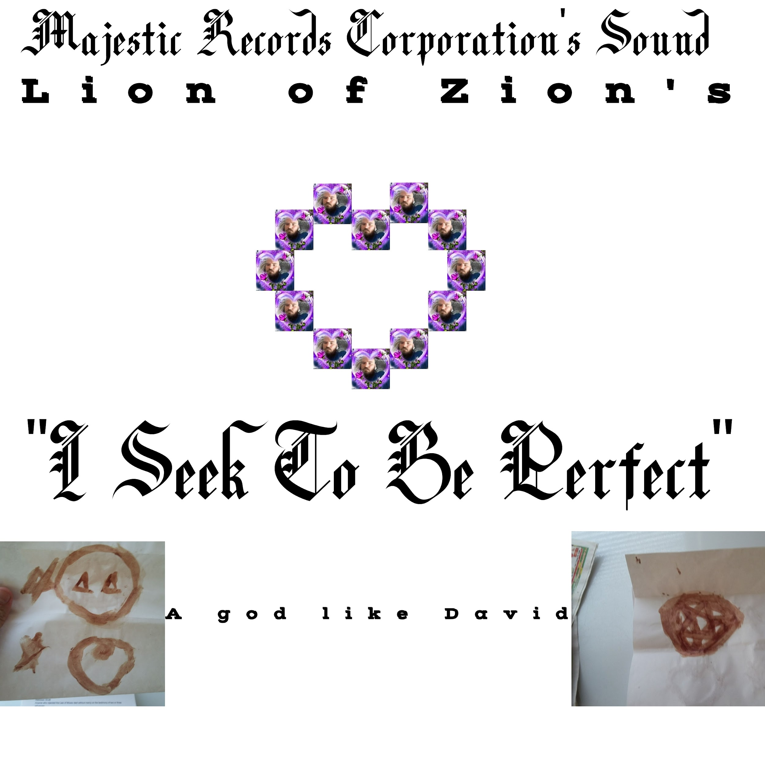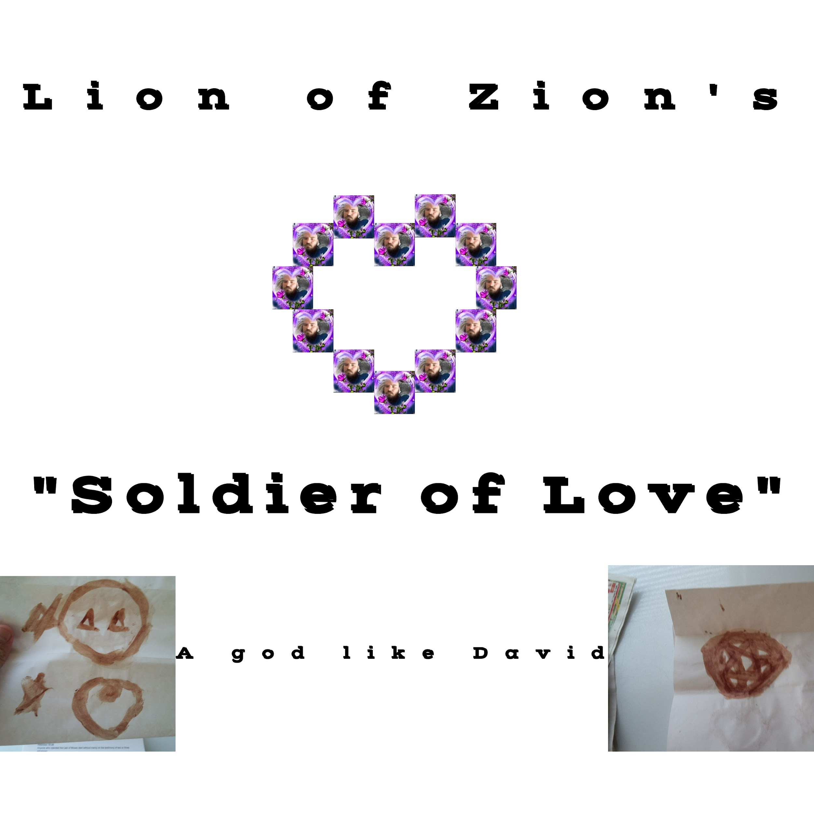 I intend to use the general design of these pieces of art and sell an entire album of fine and classy jazz. I believe the album will win a grammy and I have 3 demos that are fine, classy, and fit for Vegas Casinos. The minimal investment I seek is purchasing this album from Majestic Records Corporation. I am a staff writer and have already written the lyrics for the entire Album. I would give the instrumentals created, the demos created, the very products I intend to sell as collateral until the products yield a 200% return to the investor. I would sign a contract legally obligating a 200 percent return and giving the products as collateral until the return is paid and while the products sell online. I have contracts of this investment signed and have demos of the work on hand.
- $10,000 invested in BookWhip for the publication of a book that is based upon the website www.kingtsidkenu.com and is intended to bring health, wealth, cleanliness, happiness, and love by standard of everlasting and on land. The book and website, even the entire package this company offers, is intended to create joy for many generations via professional entertainment. I have two past publications and a website all containing hundreds of pages of intellectual treasure. I intend to pick the meat of the treasure and put the meat in the book. The Company offers 100 percent royalties with marketing and promotional efforts. They work with an independent motion picture company that makes an independent film for $120,000. Because Olive Animations desires to make a feature animation for $120,000 and because I wrote a 90 minute animation already, an independent motion picture is not part of the short term business plan, but is an option as the company moves forward. I have a contract for this investment on hand.
- $10,000, $15,000, or $20,000 to Rob Tracy’s Music Room. Rob Tracy is a professional Rock Musician I have worked with in the past. I have multiple demonstrations of his work and the man can create custom Rock and Parody Tracks. In addition to the fine and classy jazz music I wrote for Majestic Records Corporation, I wrote a Love Multiplication Demonstration Album! Rob Tracy has the knowledge and talent to make legal instrumentals like the Love containing Songs I derived my lyrics from. I intend to offer a second album where I demonstrate to this and all future generations how to multiply Love.
- $120,000 to Olive Animations for a 90 minute feature animation that includes visions I have had and things I have seen. I am pure hearted and my website and fruit attests to my character. Part of the animation is God clothed in light on his spherical throne outside an airplane I was on years ago above Salt Lake City flying to New York City. I think one other passenger on the plane saw the event, but I have sought for years to get what I have seen created by an animation company, and I wrote an entire animated movie featuring the event so I could make money with an entertaining animation featuring the things I have seen over the years. The animation is headible, edible fruit with scenes that are so intelligent, every linking verb in the English Language, relativity, the 5th amendment plea of a mafia attorney, and a campaign to promote Patron with intelligent charismatic beauty is combined in an expression of the main character. The animation is dignified and provoked a lifetime partnership request with Olive Animations. I have contracts for this investment on hand.
- $18,000 to Cincopa for unlimited streaming of the animation and sales of all the digital media for 15 years. They confirmed 15 years can be paid in advance, and they await doing business in the future.
- $5,000-$20,000 remaining money is to establish the Business as an LLC company in Nevada through a company. There is a company that offers representation in Nevada, and they mentioned the following via Email: “You asked for information about the pricing for us to form an LLC for you. The total for that would be $560 ($35 for 1 year of Registered Agent service, $100 for the business formation fee, $425 for state fees). Every year thereafter that you remain in business, you will need to file your Annual List & Business License Renewal at a cost of $350, which are the state fees. We're available to take care of that annual filing for you for an additional $100.” If there is any money left over after all the investment mentioned, the money can be returned. I get over $1000 a month that pays for my rent, food, electricity, hygiene, etc. every month. The Entire investment is intended to establish the business, make the products the business sells, and make the products known and available to the consumer.

